- To search for Follett Digital Audiobooks, type "audiobooks" in the search bar and press the enter key or magnifying glass in Destiny Discover or the "Keyword" icon in Destiny Classic.
  - Audiobooks in a school library collection may include Playaways (the audiobook on a small MP3 player including earbuds) and Follett Digital Audiobooks.
  - Playaways are displayed on the Books ribbon in Destiny Discover, labeled as Recorded Sound with the MP3 player/earbuds on the cover illustration and Call # prefix PLY.
  - Follett Digital Audiobooks are displayed on an Audiobooks ribbon in Destiny DIscover, labeled as Follett Digital Audiobook, with a Play button located to the right of the title.
Digital Audiobooks are played in the same Destiny web-based eReader as eBooks. Users must log into Destiny to check out/listen to a Digital Audiobook.

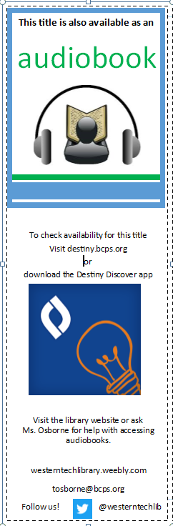

Playaways in Destiny Discover  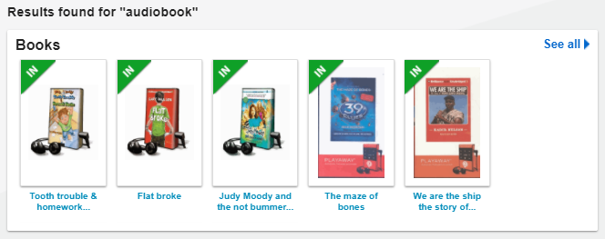 | Playaways in Destiny Classic  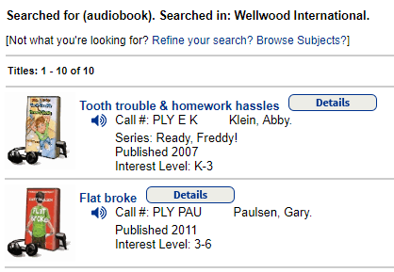
Digital Audiobooks in Destiny Discover

