How to Access Destiny eBooks
You can access our eBooks and audiobooks on the following devices:
- eReaders: Nooks, Kindle Fire (NOT regular Kindle), etc.
- Tablets: iPads, Samsung Galaxy Tab, etc.
- Laptops and Desktop Computers: MacBooks, Chromebooks, Dell computers, etc.
- Smartphones: iPhones, Samsung Galaxy, etc.

1: Download the Destiny Discover App onto your device:

- Android Phones and Tablets: Samsung Galaxy phone, Galaxy Tab
- Kindle Fire
- Mac OS X (click on the Apple icon to start the download)
- Nook
- iOS Phones and Tablets: iPhones, iPads, iPods
- Windows Desktops and Laptops (click on the Windows icon to start the download)

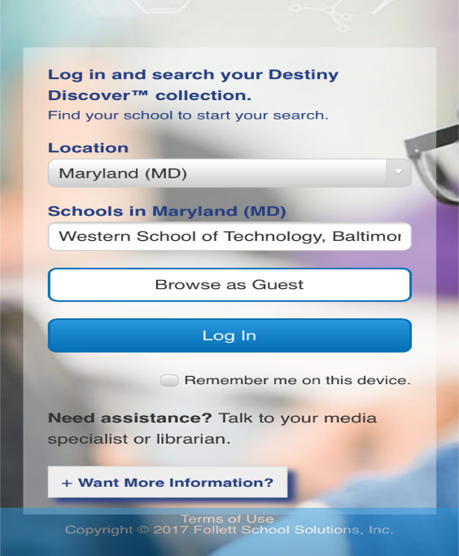
2: Login to Destiny Discover
-Open the app and enter the following information:
- Location: "Maryland"
- Schools in MD: Western School of Technology, Baltimore
-Click “Log in”

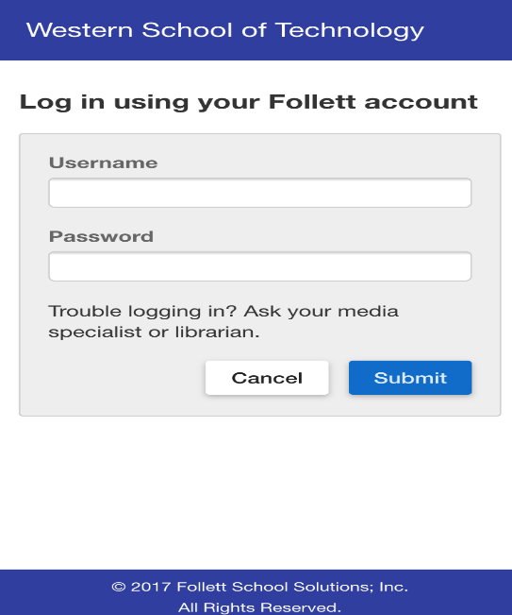
-Type in your BCPS One username and password.
*If you do not know yours, you can ask
Ms. Osborne to look it up for you*
-Click “Submit”

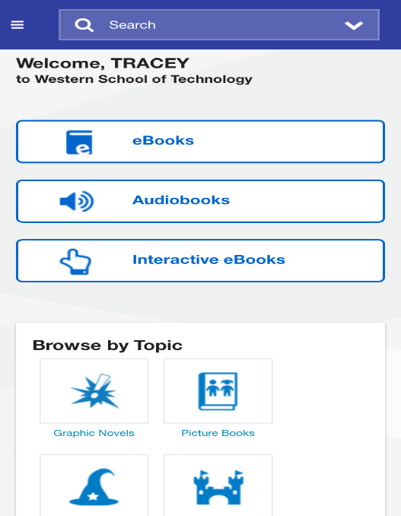
3: Browse or search within the collection:

-Click on the eBooks and/or interactive eBooks icons
to browse digital titles.

-You can also browse by topic.

-Click the search icon to locate a specific title.

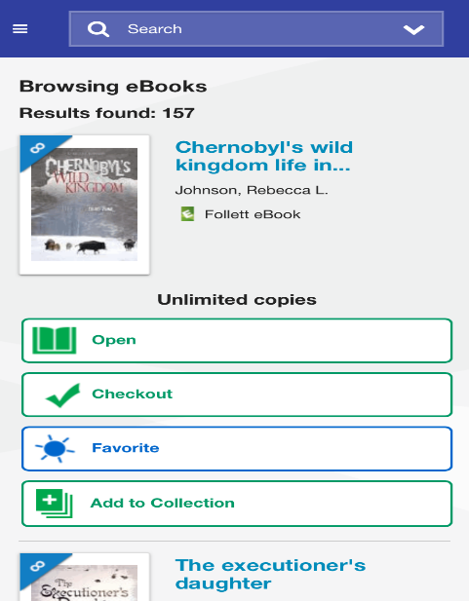
4: Checkout an eBook

Once you find a book you are interested in you can:
-Open the book to look through it
-Checkout the book to your account

5: Return an eBook
To return a book click the menu icon (three lines) at the top left hand corner of the screen and select "Checkouts." Then, click "Return" for whichever book you are finished with.
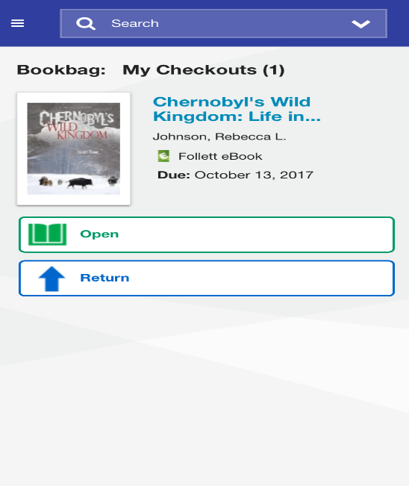
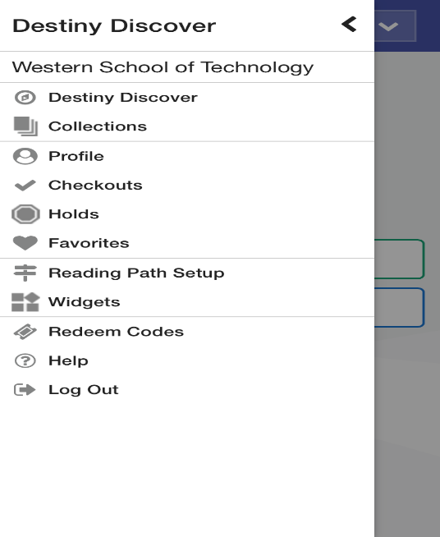

Still have questions? See Ms. Osborne in the Library or email at tosborne@bcps.org

