MLA RESEARCH HANDBOOK:
A Guide to Citing Evidence in Academic Papers

Works Cited Reference Guide for MLA, 8th Edition

Works Cited Entries (* Note: if any information is not given, skip it.)
Type of Source | Example if MLA 8 Works Cited Entry
Entire Book | Format: Author(s). Title of Book, edited by Editor, Edition, Publisher, Year. Database Name (if electronic). Accessed date.  Example (Print Book): Smith, John. Social Media Basics. Revised ed., Smithfield Publisher, 2015.  Example (E-Book): McEvoy, Sean. Shakespeare: The Basics. 2nd ed., Routledge, 2006. eBook  Collection.  *Note: If using a print book, skip the database name.
Part of a Book  (chapter, essay, story, poem, entry, etc.) | Format: Author(s). "Title of Part." Title of Book, edited by Editor, Edition, vol. #, Publisher, Year,  page number(s). Database Name (if electronic). URL or DOI (if electronic).  Example (E-Book): Hennessy, Michael. “Sinking the Titanic.” Critical Survey of Poetry, edited by  Frank Magill, 2nd ed., vol. 1, Harvard UP, 1991, pp. 80-89. Literature  Resource Center.  Example (Print): Fallows, James. “Throwing Like a Girl.” The Norton Field Guide to Writing with Readings  and Handbook, 4th ed., W. W. Norton, 2016, pp. 137-41.  Example (Print): Hemingway, Ernest. "Hills Like White Elephants." The Norton Introduction to Literature,  edited by Kelly J. Mays, shorter 12th ed., W. W. Norton, 2017, pp. 114-18.  *Note: If citing a play or novel, italicize title instead of using quotation marks.  *Note: If piece is a single page, use: p. for page number; if article is multiple pages, use: pp.
Journal, Newspaper, Magazine Article | Format: Author(s). "Title of Article." Title of Journal, vol. #, no. #, Date of Publication, page number(s).  Database Name (if electronic), URL or DOI.  Example: Godwin, John. "Wallace’s 'Jest'." Explicator, vol. 61, no. 2, 2003, pp. 122-24. General OneFile, www.explicator.com  Example (doi): Goldman, Ann. “Reading Primo Levi Reading Dante.” The Georgia Review, vol. 64, no. 1,  2010, pp. 69-88, Literature Resource Center, doi:10.1632/adfl.43.2.11.  *Note: DOI is the Digital Object Identifier. Include before the database name if provided
Articles Written for a Database | Example 1: “Wal-Mart Stores, Inc.” Hoover’s, 2016.  Example 2: “Human Trafficking.” Issues and Controversies, Infobase Learning, infobase.. Accessed 17 Nov.  2010. infobase.com  Example 3: Smith, Eric. “The Carbon Solution.” Today’s Science, Infobase Learning, July 2016, infobase.com.  Accessed 15 July 2017  Example 4: "To Kill a Mockingbird." Novels for Students, edited by Diane Telgen, vol. 2, Gale, 1997, pp. 285-  307. Gale Virtual Reference Library, go.galegroup.com. Accessed 22 Sept. 2017.
Personal Interview | Format: Interviewee. Interview. By Interviewer, Date of Interview.  Example: Smith, Jane. Interview. By John Doe, 24 Oct. 2015.  *Note: for published interviews, follow MLA format for published materials.
Website Article  (Also use for a webpage from a larger website) | Format: Author(s). “Title of Article.” Title of Website, Website Publisher (if different than title), Date of  publication, URL. Date Accessed  Example with author: Stewart, Bob. “Biostimulants.” Plant News, University of Maryland, 5 Aug. 2009,  www.ipmnet.umd.edu/5-4art1.htm. Accessed 22 Feb. 2019  Example with no author: “Giant Panda.” Smithsonian National Zoological Park, Smithsonian Institute, 2017,  nationalzoo.si.edu/animals/giantpandas/pandafacts. Accessed 20 March 2019.  *Note: Exclude publisher if title of website and publisher are the same.  *Note: Do not include the http:// or https:// in the URL. You should stop the url before numbers and unique characters begin. Often it will end with .html, .gov, .org, .com, etc. BE SURE YOU ARE CITING THE CORRECT URL NOT A SEARCH ENGINE.
Entire Website | Format: Author(s). Title of Website. Website Publisher (if different than title), Date of Website, URL. Date Accessed  Example: Museum of Natural History. Smithsonian, 2012,  www.mnh.smithsonian.gov. Accessed 12 Jan. 2018.
Internet Video | Format: Author(s). “Title of Video.” Website Title, Website Publisher (if different than title), uploaded by  Name of User, Date of Upload, URL. Date accessed.  Example 1: “Biology: Cell Structure.” YouTube, uploaded by Nucleus Medical Media, 18 Mar. 2015,  www.youtube.com/watch?v=URUJD5NEXC8. Accessed 5 June 2017.  Example 2: Raqib, Jamila. “The Secret to Effective Nonviolent Resistance.” TED, Nov. 2015,  www.ted.com/talks/jamila_raqib_the_secret_to_effective_nonviolent_resistance.  Accessed 12 July 2016.
Image on the Web | Example: “Migrant Mother.” Prints & Photographs Reading Room Collection, Library of Congress, 11 Jan.  2004, montevideo.usembassy.gov. Accessed 5 January 2017.  *Note: For images without titles, create a descriptive title in plain text – no italics, no quotes.  *Note: Italicize titles of formal art work.
Authors/ Number of Authors | Format | Example
No Author | If no author given, skip the author and start with the title of source.
1 Author | Last Name, First Name. | Smith, John.
2 Authors | Last Name, First Name, and First Name Last Name. | Smith, John, and Mary Fields.
3+ Authors | Last Name, First Name of First Author, et al. | Smith, John, et al.
Association or Company | The name of the association or company. If a work is written and published by an organization, list the organization as publisher only. | American Cancer Society.  Microsoft.
Pseudonyms  *Note: Caution-this could indicate a lack of credibility | Use pseudonyms and online usernames like regular author names. | @jsmith.
Editor or Other Role | If the role of that person or group was something other than creating the work’s main content, follow the name with a descriptive label. | Smith, Geoffrey, editor.  Perry, Tyler, performer

ADDITIONAL INFORMATION
For additional source types or for more information, please visit the Purdue Online Writing Lab https://owl.english.purdue.edu or Easybib www.Easybib.com. CAUTION: If using a citation generator or provided citation, always check it against this handout or other MLA 8 reference guide. You are responsible for verifying the information.

Format of the MLA 8 Works Cited Page
Quick Facts:
- The Works Cited list typically appears at the end of a paper.
- Name the page “Works Cited.” While “Bibliography” and “Literature Cited” are sometimes used, Works Cited is often the most appropriate.
Note: An Annotated Bibliography is different than a Works Cited list. An annotated bibliography includes brief summaries and evaluations of the sources.
- Make the Works Cited page the next consecutive page number. If the last page of your project is page 12, the Works Cited list will be page 13. To add a page number to the header: Click Insert > Page # > Top of Page > Plain #3. Type your last name before the page #.
Format of the Paper:
- Use one-inch margins around the paper. Double-space the entire document. Use 12 pt. standard font (i.e. Calibri, Times New Roman)
- Place the title of the page (Works Cited) in the center of the page, an inch from the top.
- Create a double space between the title (Works Cited) and the first citation.
- Each citation should start on the left margin (one inch from the side of the paper).
- For longer citations, indent the second and any subsequent lines one half inch from the beginning of the citation. This is called a hanging citation. Click Paragraph, Indents and Spacing, and change Special to “Hanging” (see image below) hanging citation. Click Paragraph, Indents and Spacing, and change Special to “Hanging” (see image)
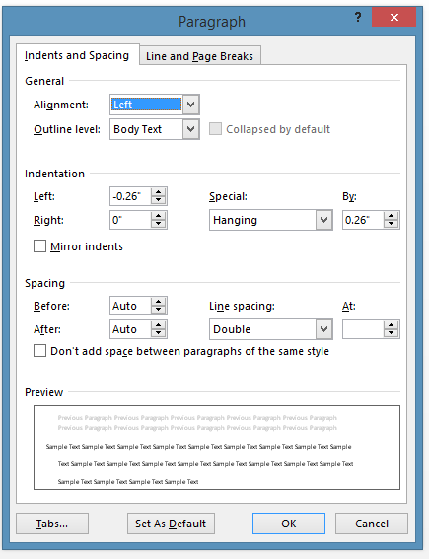
Example of a hanging indentation:

Ko Kondō, Marie. The Life-changing Magic of Tidying Up: The Japanese Art of Decluttering and Organizing. New York: Ten Speed, 2014.

Format of Citations: Place citations in alphabetical order by the author’s last name. If there are two works by the same author, alphabetize by the last name of the second author (if there is one). If there is only the single author, alphabetize by the title of the work.
THE DOCUMENTATION ROADMAP—it might be helpful to think about citing sources as a “roadmap” that leads readers all the way back to the sources you used. 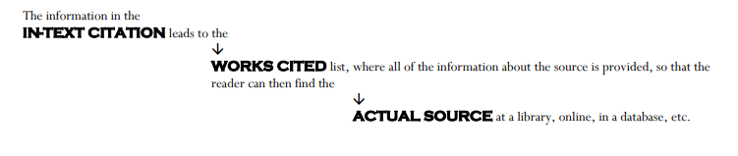

SAMPLE MLA WORKS CITED PAGE
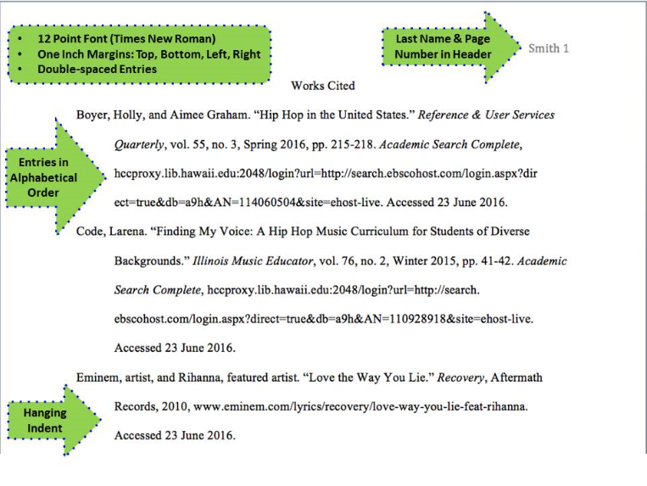
Image Source: http://libguides.hcc.hawaii.edu/citingsources/mla8

Quoting and In-Text Citation Using MLA Guidelines
This handout is designed to help you learn how to quote and cite information properly in your writing. Anytime you use information from an outside source – a book, an essay, an article, an online source, even a YouTube video – you MUST give credit to that source by documenting it in two ways: in an in-text citation and on your works cited page. Documentation clearly indicates to your reader which information you borrowed from sources. Not documenting sources constitutes plagiarism (or academic dishonesty), and offence that can result in a failing grade on an assignment or in the course, and.or other administrative consequences. The basic rules for documenting sources are:
1. Direct quotes (exact language from a source) must be enclosed in quotation marks (“ ”) and followed by an in-text citation
2. Paraphrases must be carefully constructed and also be documented by in-text citations
3. Page or paragraph numbers (when available) should always be included in in-text citations
4. In-text citations should clearly match the works cited entries at the end of your document
5. Works cited entries should be complete and accurate

Basic Rules for In-Text Citation
- All in-text citations follow the same pattern:
The writer says, “Outside Brown, quitters are no heroes” (Neusner 261).
quotation mark, text, quotation mark, space, parenthesis, author's last name, page number, parenthesis, period.

- If the author’s name is contained in the sentence, however, it does not need to appear in the parentheses:
Neusner says, “Outside Brown, quitters are no heroes” (261).

- There are two exceptions:
1) Long Quote: If you use a long quote (more than four lines), there are NO quotation marks and the punctuation goes before the citation (see the section on “Long Quotes” on this handout for details).
2) Quote with Different End Punctuation: If the quote ends with a question mark or exclamation point rather than a period, keep the punctuation that the original author uses (see “Quotes with Different End Punctuation” on this handout for details).

- Once you have quoted something and cited it, if you use any or all of the same words again, no citation is necessary – quotation marks, however, must still be used to indicate to your reader that you are presenting someone else’s words.
For example: First reference: The author says, “quitters are no heroes” (Neusner 261).
Subsequent reference: Therefore, students should realize that “quitters are no heroes.”

- One last thing to remember – When you quote an author in an essay or paper, the first time you mention that author, you must provide the full name. After that first time, use the last name only in all subsequent references to that author.

Proper Punctuation and Formatting for Quoting an Author
- Simple Quote
Neusner says, “When you did not keep appointments, we made new ones” (261).
If the author is not indicated in the sentence, his/her name goes inside the parentheses:
One professor says, “When you did not keep appointments, we made new ones” (Neusner 261).

- Quote from Someone Other than the Author of the Original
Professor Carter A. Daniel of Rutgers University says, “We had to do it, for the sake of education” (Neusner 261).
This kind of quote follows the rules for a simple quote. Notice, however, that the author (Neusner) did not say these words: Professor Carter A. Daniel did. In this case, I introduce the quote using Daniel’s name to indicate that someone other than the author of the text spoke/wrote the words.
If I do not name Daniel in the sentence before the quote, the quote would look like this instead:
It has been said, “We had to do it, for the sake of education” (Daniel qtd. in Neusner 261).
This way, the reader knows that the author (Neusner) did not actually say these words but was quoting someone else. [“qtd. in” stands for “quoted in”]

- Quote Introduced with “that” & Quote with an Ellipse (in the middle of the quote)
The author tells us that “We have prepared you for a world...that cannot exist” (Neusner 261).
Notice this quote uses no comma and no colon. This is because I used the word “that” before the quote. When introducing a quote with “that” a comma or colon is never used.
Notice, too, the ellipse (…). Ellipses indicate that I have omitted (or left out) a part of the text.
- Incorporating a Quote & Quote with an Ellipse (at the end of the quote)
Obviously our professors think we are “peer-paralyzed adolescents...” (Neusner 261).
This quote has no comma or colon before it. That is because I am using the author's words to finish my sentence. This is called incorporating a quote. When you incorporate, no comma or colon is used.
Notice, too, that after the quote is an ellipse (...). The ellipse indicates that there is more to Neusner's sentence and I didn't finish it.
The idea of using an incorporated quote is not to quote any more than you need to. Too many quotes distract the reader and weakens your ethos (credibility) as a writer.
NOTE: You NEVER use an ellipse at the beginning of a quote. This is because the use of lowercase or capital will indicate to your reader whether your quote begins at the start of the original sentence or in the middle of the original sentence.
For example: A capital letter tells your reader that the quote begins at the start of the original sentence:
Neusner says, “Outside Brown, quitters are no heroes” (261).
A lowercase letter indicates that you have left out the beginning of the original sentence:
Neusner says, “quitters are no heroes” (261).
- Paraphrasing
College professors think of their students as a bother, as people to be gotten rid of, nuisances they pass merely to get them to go away (Neusner 261).
Notice here that there are no quotation marks at all. This sentence is paraphrased. I borrowed the idea—none of the words, just the idea—from Neusner, so I gave him credit for the idea. Without this citation, I would be plagiarizing. If I used any of Neusner’s phrasing at all, I would have to put quotation marks around his words.
- Interrupted Quote
"Try not to act toward your coworkers and bosses,” says Neusner, “as you have toward us” (261).
This is called an interrupted quote. It is a variation of the simple quote. Try to vary the way you quote. It makes your paper more interesting to read and shows your strength as a writer.

- Introducing Quotes with a Colon
Professors have been pretending to care for years: “when you were boring, we acted as if you were saying something important” (Neusner 261).
This quote is introduced with a colon. A colon indicates that the quotation is an explanation of or example for the sentence I just wrote: “when you were boring (etc)” is an example of the pretending of professors I am talking about before the quote. The thing to remember about using a colon to introduce a quote is that you must provide a complete sentence of your own before the colon, and then a complete sentence of quote after the colon.

- Long Quote
A long quote is any quote that is more than four lines.
Neusner points out:
We the faculty take no pride in our educational achievements with you. We have prepared you for a world that …cannot exist. You have spent four years supposing that failure leaves no record. You have learned...that when your work goes poorly, the painless solution is to drop out. But starting now, in the world to which you go, failure marks you. Confronting difficulty by quitting leaves you changed. Outside Brown, quitters are no heroes. (261)
Neusner is at least partly right. Often, students will drop out of a class that isn’t going the way they want it to or if they are not getting the grade they want.

This is an example of a long quote. Notice a few things:
First, the quote is introduced with a colon (:). All long quotes should be introduced in this way.
Second, notice that the ending punctuation goes before the parentheses. All long quotes leave the punctuation before the citation and have no period after.
Third, there are no quotation marks and the quote is indented TEN spaces, not five (two “TAB” spaces, not one). The whole quote has to be ten spaces over from the left margin. The right margin remains the same. This formatting indicates that you are presenting a quote, so no quotation marks are needed.
Fourth, notice that the line after the long quote starts back out on the left margin without indenting. Because you should never quote without responding, long quotes generally have a sentence or more afterward that is still part of the same paragraph. This is indicated by the sentence beginning all the way out to the left margin.

- Quotes with Different End Punctuation (? and !)
After ranting about how badly he has treated his students, Neusner asks, “And all this why?” (261).
This is an example of a quote that has different end punctuation—a question mark or an exclamation point. Here, the question mark is part of the quote from Neusner, so it remains inside the quotation marks and there is still a period after the citation.
The only exception is if YOU ask the question. If the question mark or exclamation point is YOURS, you put it after the citation. For example: Do you think students will “unlearn the lies” (Neusner 261)?

- Quotes with Added Words and/or Corrections (Using Square [ ] Brackets)
Sometimes, you need to change a word, a verb tense, add a word, or otherwise adjust the grammar in a quote for it to make sense, or make more sense, to your reader. Square brackets—[like these]—are used to indicate that you have added or changed something for clarity.
Is it possible to “unlearn the lies [professors] taught [students]” (Neusner 261)?
Above, I have substituted the word [professors] for “we” and the word [students] for “you” to clarify who I the quote refers to.
Neusner warns students to “Try not to act towards … coworkers and bosses as you have acted towards us [professors]” (261).
In this quote, I have added the word [professors] after “us” to clarify who the quote refers to.

AND ONE THING TO AVOID…
- The Floating (or Orphan) Quote
I am so tired of teachers blaming their students for their incompetence. “When you were dull, we pretended you were smart” (Neusner26 1). He even admits that he told us we were smart. What were we supposed to think?
This is what I call a floating or orphan quote. Notice it stands all alone with no words of my own to introduce it, follow it, or make it flow well into my writing.

The simplest way to fix this problem is with a colon:
I am so tired of teachers blaming their students for their incompetence: “When you were dull, we pretended you were smart” (Neusner 261). He even admits that he told us we were smart. What were we supposed to think? The error most often happens when a colon would be appropriate anyway.
But if a colon doesn’t really work, simply mentioning the author—turning it into a simple quote—is acceptable:
I am so tired of teachers blaming their students for their incompetence. As Neusner says, “When you were dull, we pretended you were smart” (261). He even admits that he told us we were smart. What were we supposed to think?

Source: Adapted from http://www.ftschool.org/fts/_zumu_user_doc_cache/MLA_Quoting_and_Citing_Guidelines.pdf

