NoodleTools Quick Guide for Students

1. How to create a new account
At the Sign In page you have two options: select Office 365, enter your Office account email in the field on the right and click Sign In.

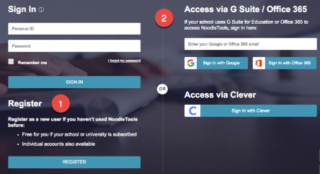
After you sign in, you should see the Projects screen:

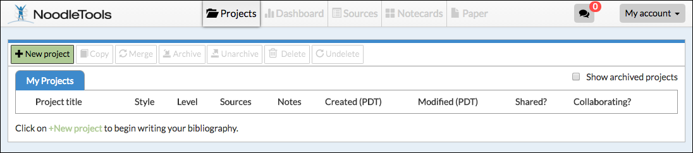

2. How to start a new project and a source list
1. On the Projects screen, click New project.
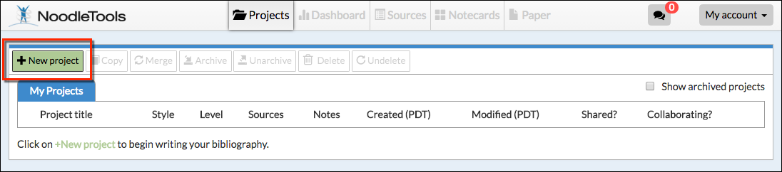
2. On the Create a New Project screen that pops up, enter a name for your project and select the appropriate citation style and level. Click Submit. NOTE: Once you create a project, you will be able to switch seamlessly between styles and levels. So what you set up now can be changed later with one click.
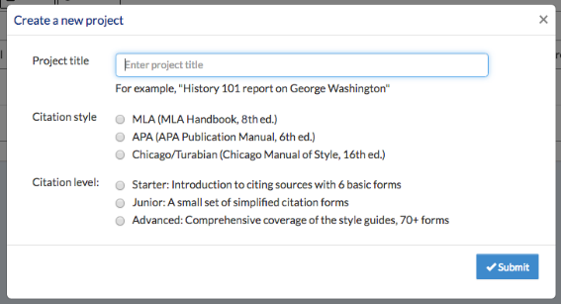
3. The Dashboard screen appears. The Dashboard organizes your work environment for effective research. You can see assignments, create to-do lists, submit work, and act on feedback from teachers in an organized way, and all in one place.

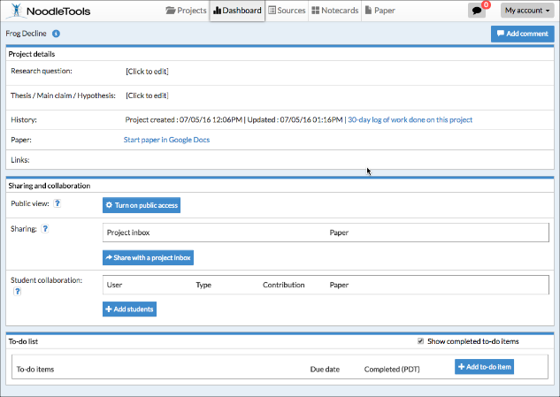
4. To begin citing sources, click Sources in the navigation bar at the top.
5. On the Sources screen, click Create new citation and select the best match for your source from the choices given.
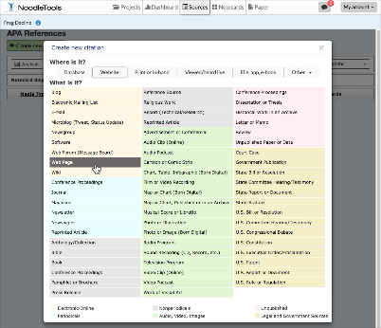
Note: On the next screen, depending on the citation type selected, a Show Me tutorial may be available to help you evaluate the source. The lessons are differentiated based on which level you are in: Starter, Junior, or Advanced. Below is an example of a slide from the Show Me tutorial for Website, Junior level.

6. Click Continue to go to the next screen.
7. Fill in the citation form with information about your source. If your source is a book, you can locate the book in WorldCat (via an ISBN number or title/author search) and it will automatically fill in the form with the book's details, checked and revised for accuracy by NoodleTools.
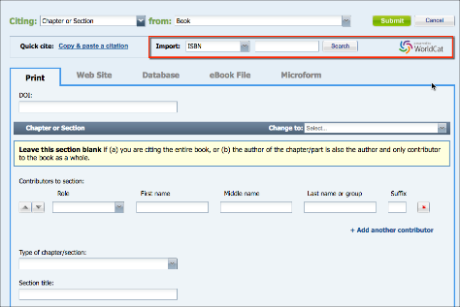

8. After you finish entering information about your source, click Submit to save your new citation.

3. How to create notecards
1. Click Notecards in the navigation bar at top.
2. On the Notecard Tabletop, click New.
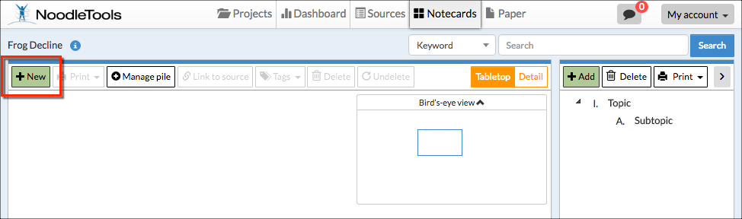
3. Input notes about your source.

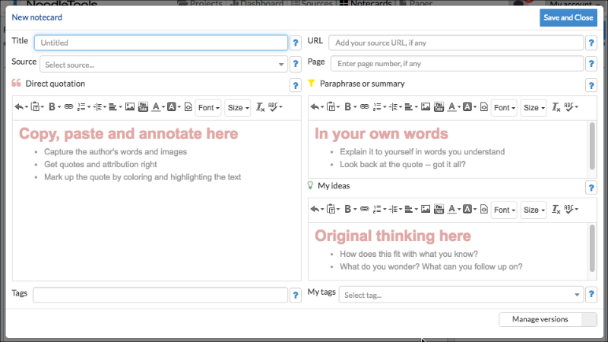

4. Your notecard gets saved automatically as you add information. When you are done, click Save and Close to save your final changes and close the window. New notecards appear in the upper left corner of your tabletop and in the bird's eye view.

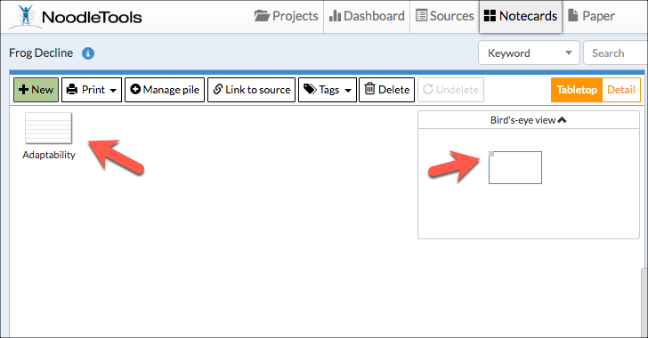

TIP: Once you've created multiple notecards, you can pile them. Drag a notecard and drop it on another notecard to create a new pile, or use the Manage pile option above the tabletop to manage existing and create new piles with selected notecards. Notecard piles become the basis of organization within the Outline panel next to the Notecard Tabletop.

4. How to share a project with your teacher

1. On your project's Dashboard screen, under Sharing, click Share with a project inbox.

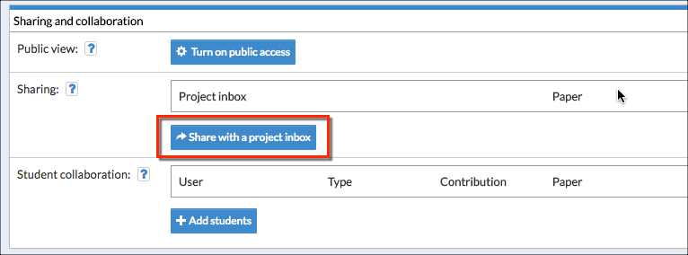

2. In the Project inbox field, enter the name of the inbox (as provided by your teacher). When the first letter of the inbox’s name is entered, a drop-down menu will appear and the name of the drop box can be selected.
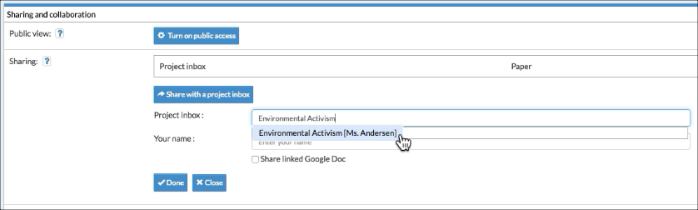
3. Enter your name so that your teacher can identify you (if not clear from your username).

4. Click Done.

5. On the Dashboard screen you will now see the inbox’s name under Project inbox.

6. On the Projects screen, you will see a checkmark in the Shared? column.
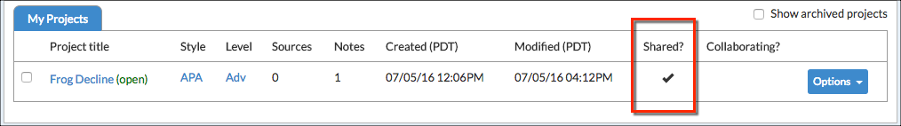

5. How to set up a project collaboration with your classmates
1. On the project's Dashboard screen, under Student Collaboration, click Add students.
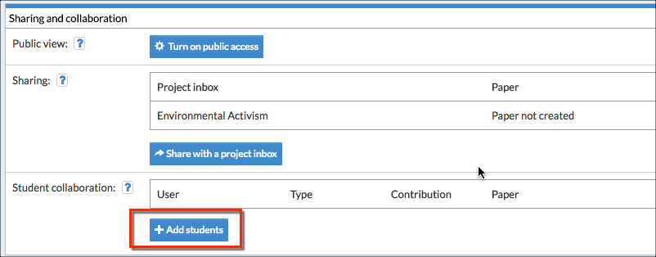
2. In the field that opens up, enter the collaborator's Personal ID. You can select Full collaborator if you wish to allow full add/edit/delete access, or Peer-reviewer if you want to share it as read-only (with just the ability to receive comments). If you need to add more collaborators, click Add more.
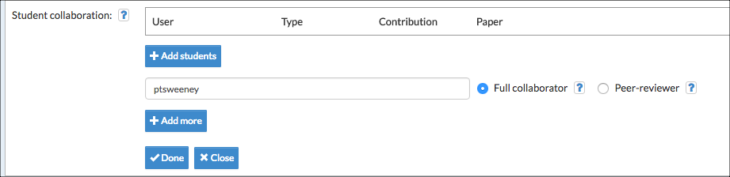
3. Click Done. All collaborators added are displayed on the dashboard for the project.

