- STUDENTS AND PARENTS need to get set up on BCPSOne.

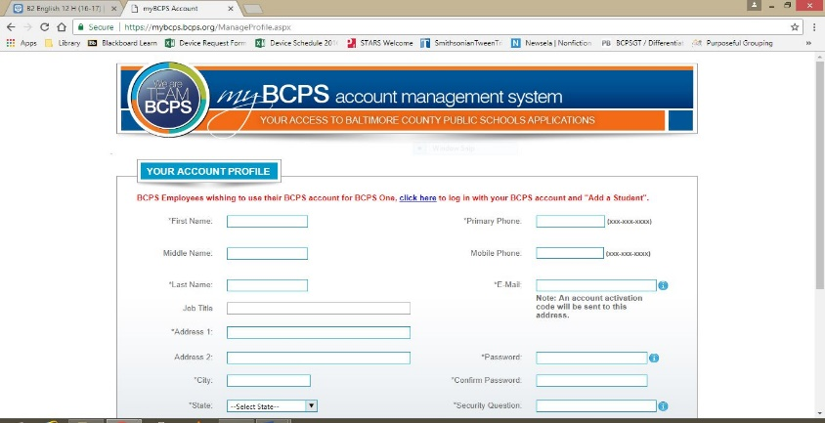
This will be your way to access grades, digital resources, digital tools and products, communicate with teachers, and more

To set up your BCPS account https://mybcps.bcps.org/ManageProfile.aspx

OR

To log in if you already have an account
https://bcpsone.bcps.org/

- Install the MICROSOFT 360 Suite of products for free!

MICROSOFT OFFICE 365 STUDENT ADVANTAGE PROGRAM
Office 365 gives you access to the full suite of Microsoft Office products like Word and PowerPoint. Because Office 365 is online it is great for productivity, collaboration, and presentation. Microsoft Office 365 also allows for sharing and collaboration on documents and files.
- Free Download and Cloud Storage for Microsoft Office Products!
- Word, PowerPoint, Excel, and Publisher
- For Enrolled BCPS students and family members
- Includes 5 copies per BCPS student for computers and mobile devices
SETUP GUIDE:
1) Open a Web browser.
2) Enter www.bcps.org/Office365 in the address bar OR from BCPSOne, click Instructional Tools, MSOffice 365.
3) At the Sign in screen, login with your full BCPS student username and add “@bcps.org”
4) Enter your internal password.
5) On the Installation page, make sure the Language is set to “English (United States)” and then click install.
*Note: BCPS does not recommend installing the 64-bit installation due to compatibility issues.

- Check out the resources and databases listed under Digital Content and Instructional Tools on BCPSONE (see list of databases handout for an overview)

- Try out some of the free online study tools available Baltimore County Public Library databases* http://www.bcpl.info/databases.html (a few of the options are listed below)

*BE SURE TO GET YOUR LIBRARY CARD AND SET UP YOUR ONLINE ACCOUNT TO GAIN ACCESS TO SOME GREAT, FREE RESOURCES.
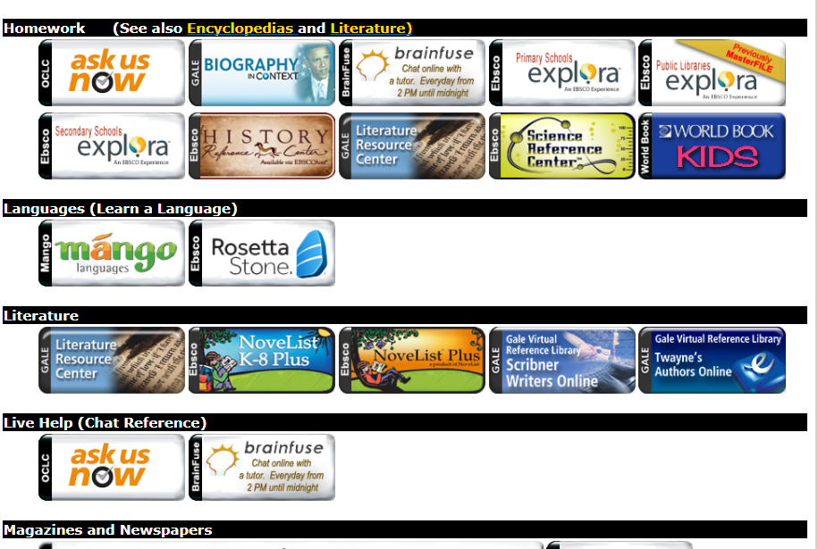

- Try out free test prep websites and other free online resources. As you find sites that are helpful, be sure to bookmark, Pin, or save them for quick access later.
  - Collegeboard.org- free practice tests, tips, study plans for SAT, PSAT, and AP
  - khanacademy.org- tutorials on many topics!
  - BCPL Homework Help: http://www.bcpl.info/kids-teens-parents-teachers/homework-teens
  - BCPS Homework Help resource list: http://www.bcps.org/offices/dpd/homework_help.html
  - Hippocampus.org- wide-range of study tools and resources

